Unified Modeling language (UML)

It's used to express an idea not a methodology

Modeling Describing a software system at a high level of abstraction

Unified UML is a world standard

It is a industry standard graphical language for specifying, visualizing, constructing and documenting the artifacts of the software system

The UML uses mostly graphical notations to express the Object Oriented analysis and design of the software projects

Simplifies the complex process of software design

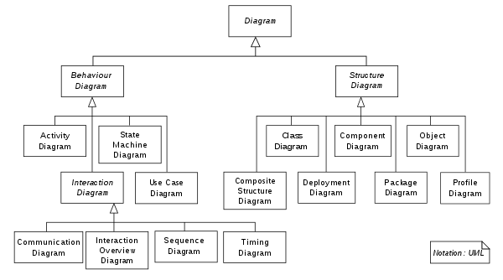

A use case is a model of the interaction between

* External users of a software product (actors) and

The software product itself

An actor is a user playing a specific role

* Describing a set of user scenarios
* Capturing user requirements
* Contract between end user and software developers..

## Class diagram

A class diagram depicts classes and their interrelationships

Used for describing structure and behavior in the use cases

Provide a conceptual model of the system in terms of entities and their relationships

Used for requirement capture, end user interaction

Detailed class diagrams are used for developers

Class represented by a rectangle

Name attributes operations

Modifiers are used to indicate the visibility of the attributes and operations

* Is used to denote public visibility (everyone)

# is used to denote protected visibility (friends and derived)

* Is used to denote private visibility (no one)

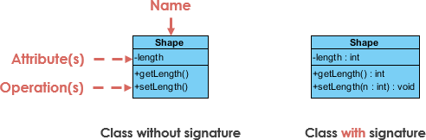

There are two kinds of relationship

Generalization (parent child relationship)

Association (student enrolls in course)

Associations can be further classified as

Aggregation

Composition

Association Models the part whole relationship

Composition

Also models the part-whole relationship but in addition every part may belong to only one

Basically part of their owner, lives or dies with their owner

Aggregation expresses instances of related classes. It is a specific kind of container container relationship

That might exist outside of their owner or sum

Apples may exist independent to a bag

Expresses a more informal relationship than composition expressess

Aggregation is appropriate when container and containee have no special access privileges to each other.

CRC card (Class responsibility collaborator)

Easy to describe how classes work by moving classes around: allows us to quickly consider alternatives

Interaction diagrams

Shows how objects interact with each other

UML supports two types of diagram

* Sequence diagram
* Collaboration diagram